|  |  |
| --- | --- |
| **Exp. No:** | **MODELLING AND SIMULATION OF**  **WHEELED (MOBILE) ROBOT** |
| **DATE:** |

# AIM

To Model and Simulation of Wheeled Mobile Robot using SolidWorks and MATLAB.

# SOFTWARE USED

* SolidWorks
* MATLAB

# THEORY

## MOBILE ROBOT

A Mobile Robot is a robot that is capable of locomotion. It is a machine controlled by software that use sensors and other technology to identify its surroundings and move around its environment. Mobile robots function using a combination of artificial intelligence (AI) and physical robotic elements, such as wheels, tracks and legs. It is usually considered to be a subfield of robotics and information engineering.

# PROCEDURE

## CAD MODELLING

The modelling in SOLIDWORKS was kept very simple so that, when the model is moved to MATLAB environment the assembly of over defined and complex system makes the simulation to take more computing time.

Step 1: Design of Mobile Robot components in SOLIDWORKS.

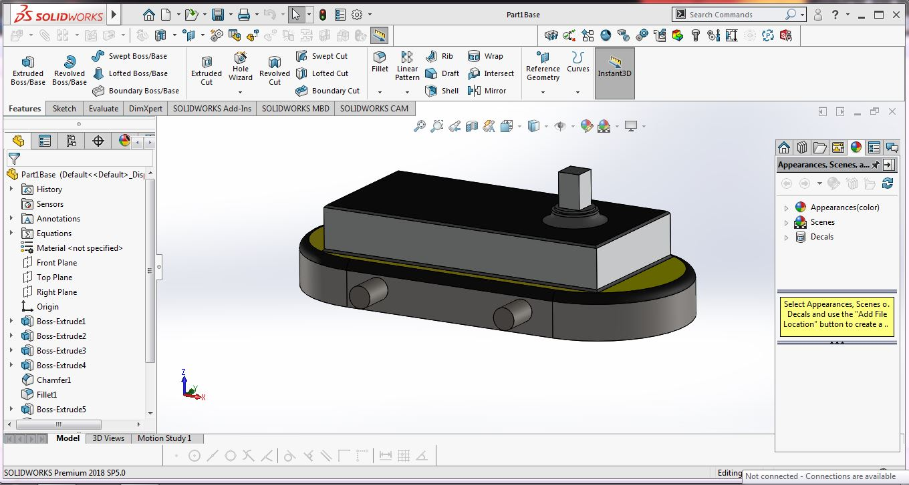

## Fig 1. Base Frame of Mobile Robot.

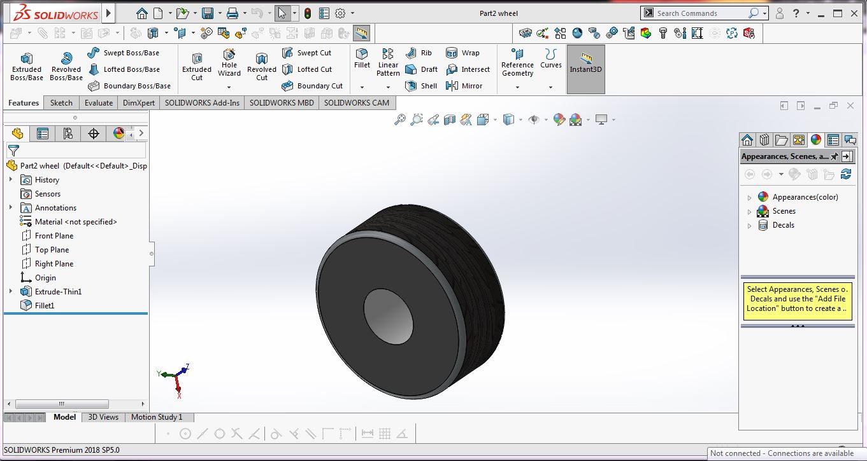

**Fig 2. Wheel**

Step 2: Assemble robot model and convert into .XML file in Solidworks for simulating in MATLAB.

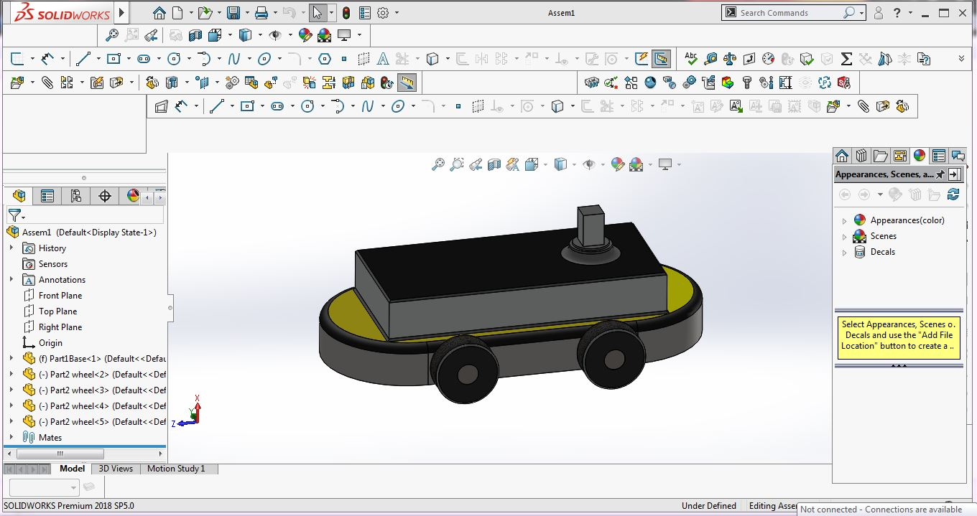

## Fig 3. Assembly of Wheeled Robot

**SIMULATION**

Step 3: Import .XML file in MATLAB. After importing the file, the equivalent simulink blocks will create for Mechanical Model.

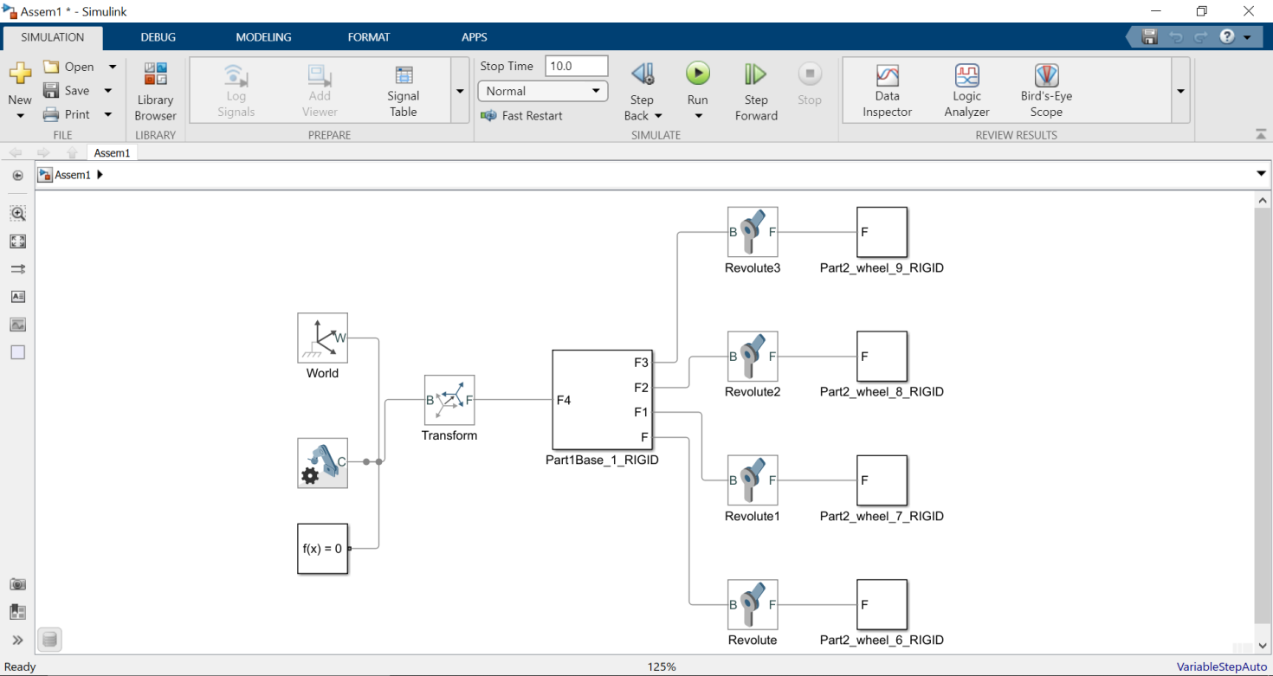

## Fig 4. Blocks of Mechanical Parts.

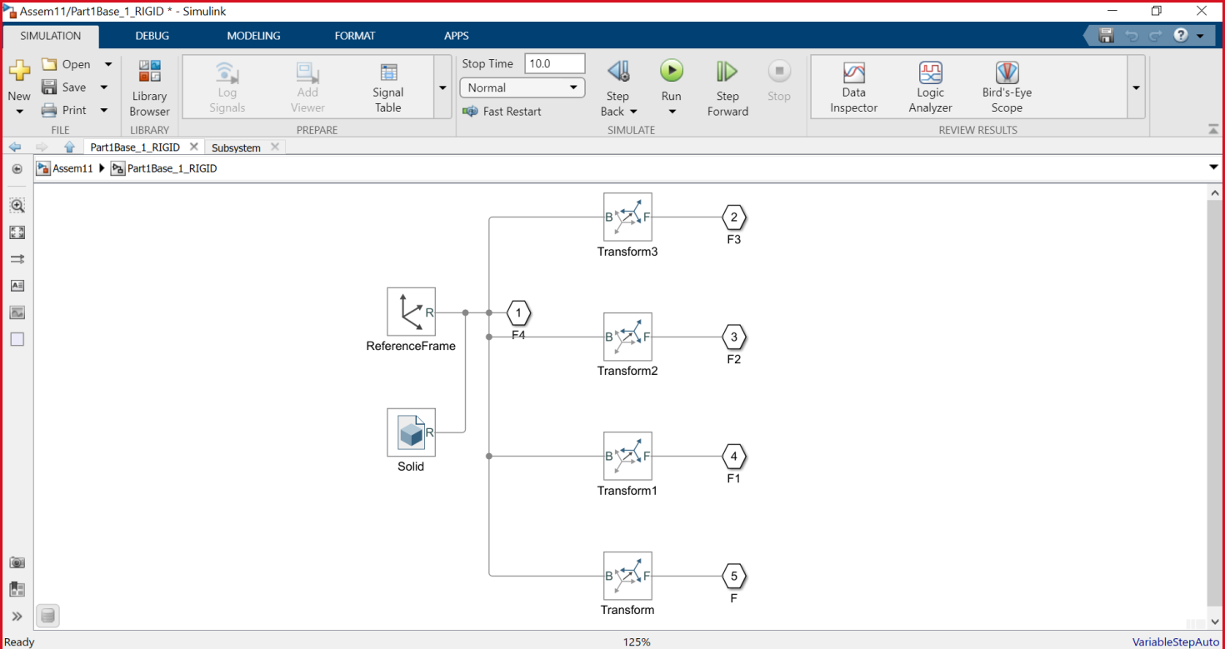

**Fig 5. Blocks Expansion.**

Step 4: Simulating the model without actuators.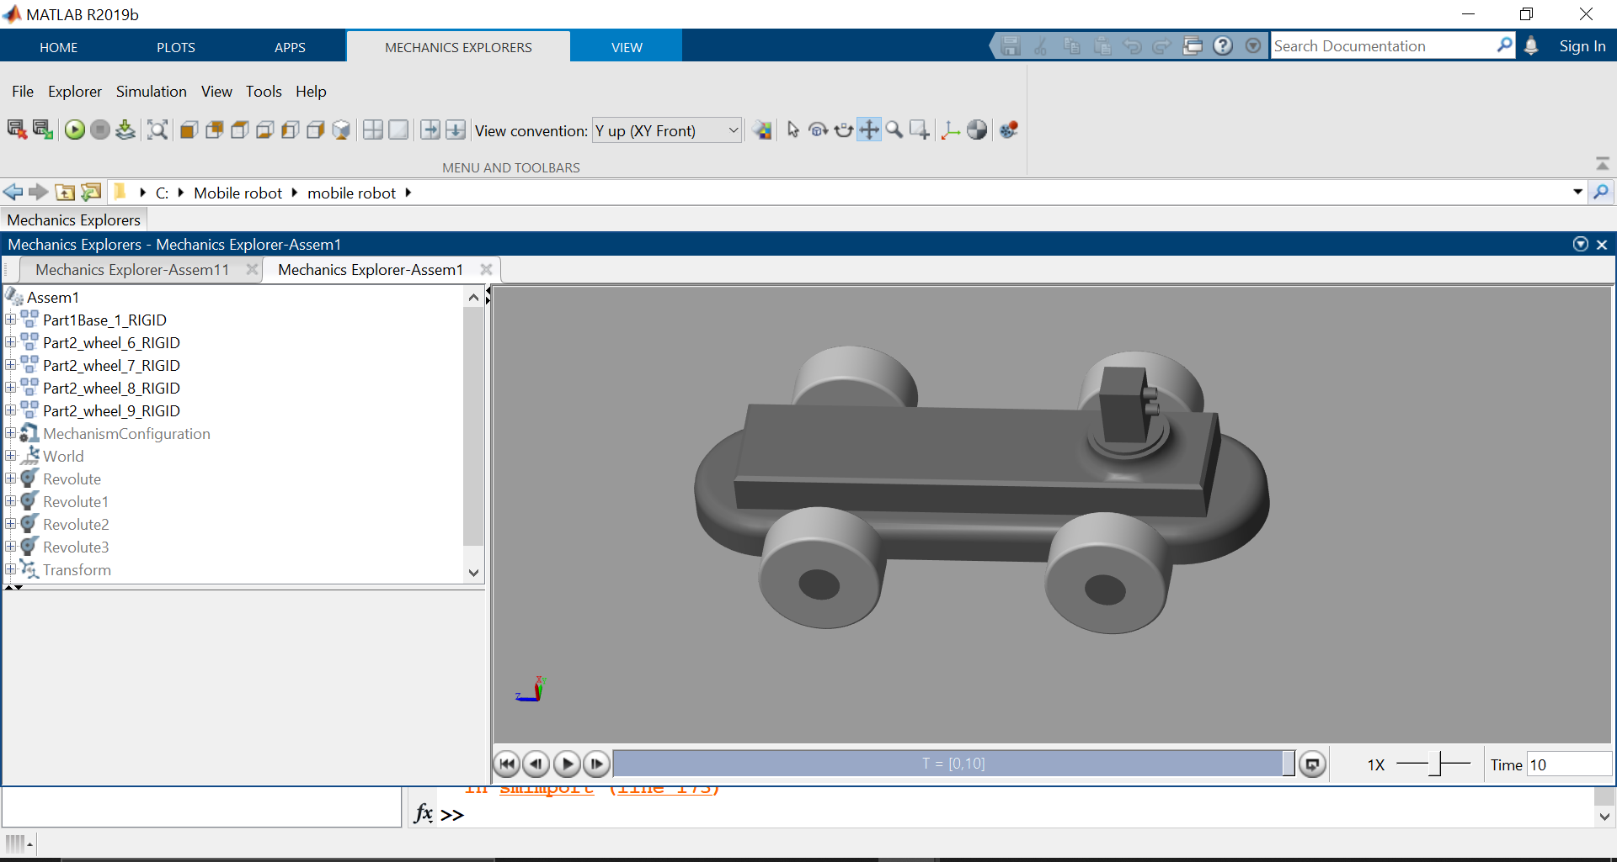

## Fig 6. Without Actuators.

Step 5: Insert the actuators and drive blocks from simlink for simulation, blocks such as Motor, Motor Drive, Power source etc.

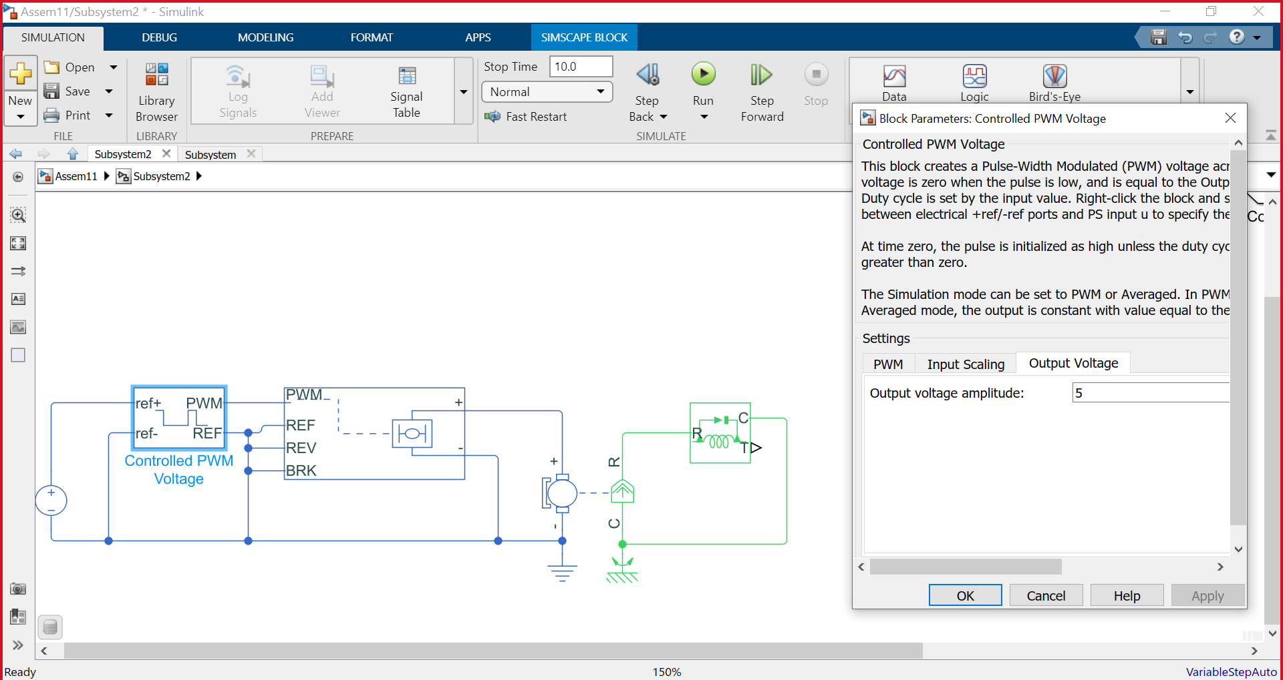

## Fig 7. Simulink - Electrical Blocks

Step 6: Connecting the Mechanical block with actuator and drives for simulation.

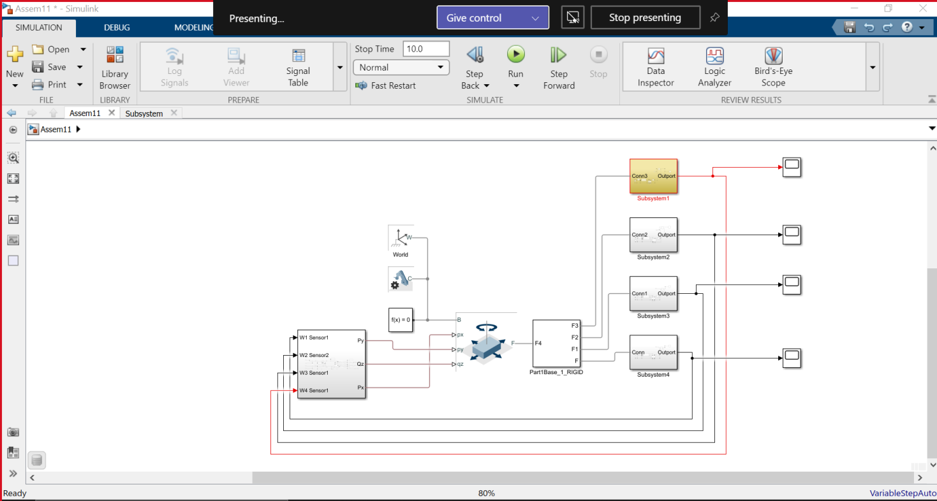

## Fig 8. Simulink Blocks of model.

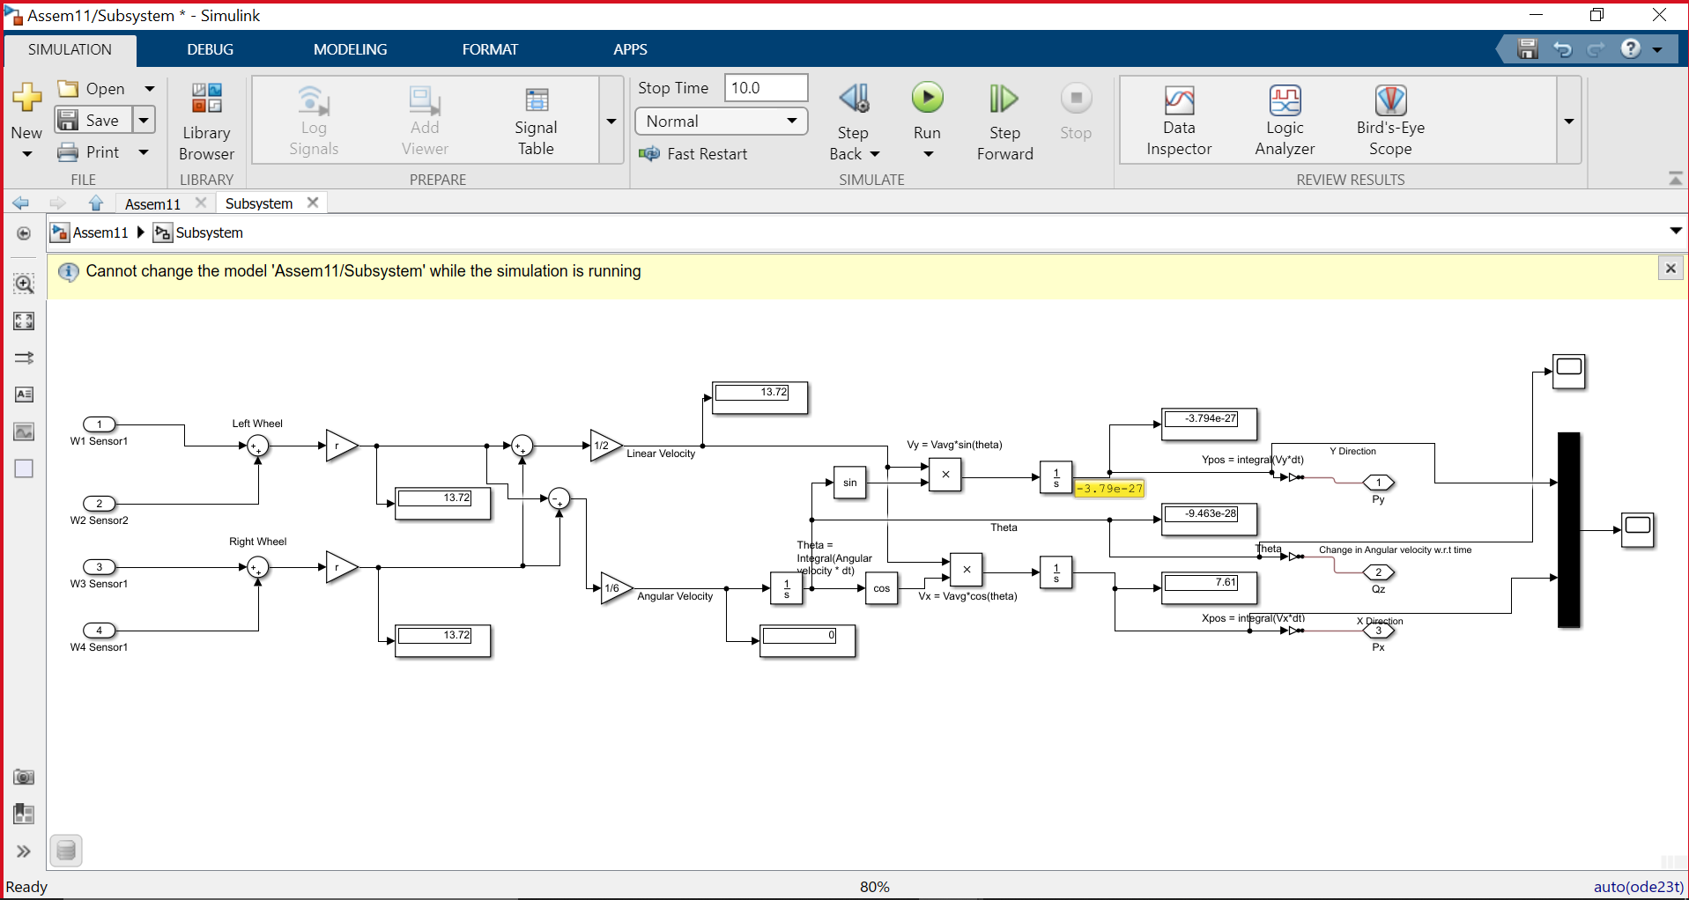

## Fig 9. Kinematic Subsystem.

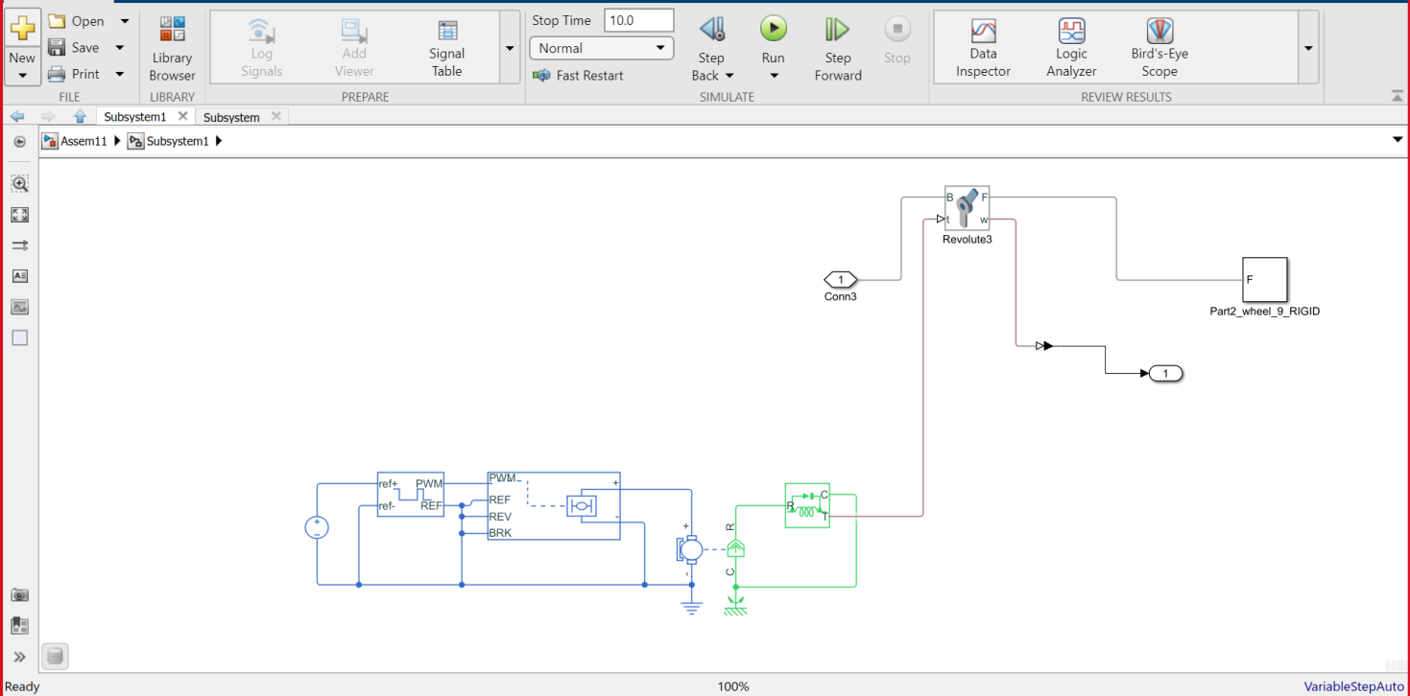

**Fig 10. Wheel Subsystem**

Step 7: Simulating simulink model.

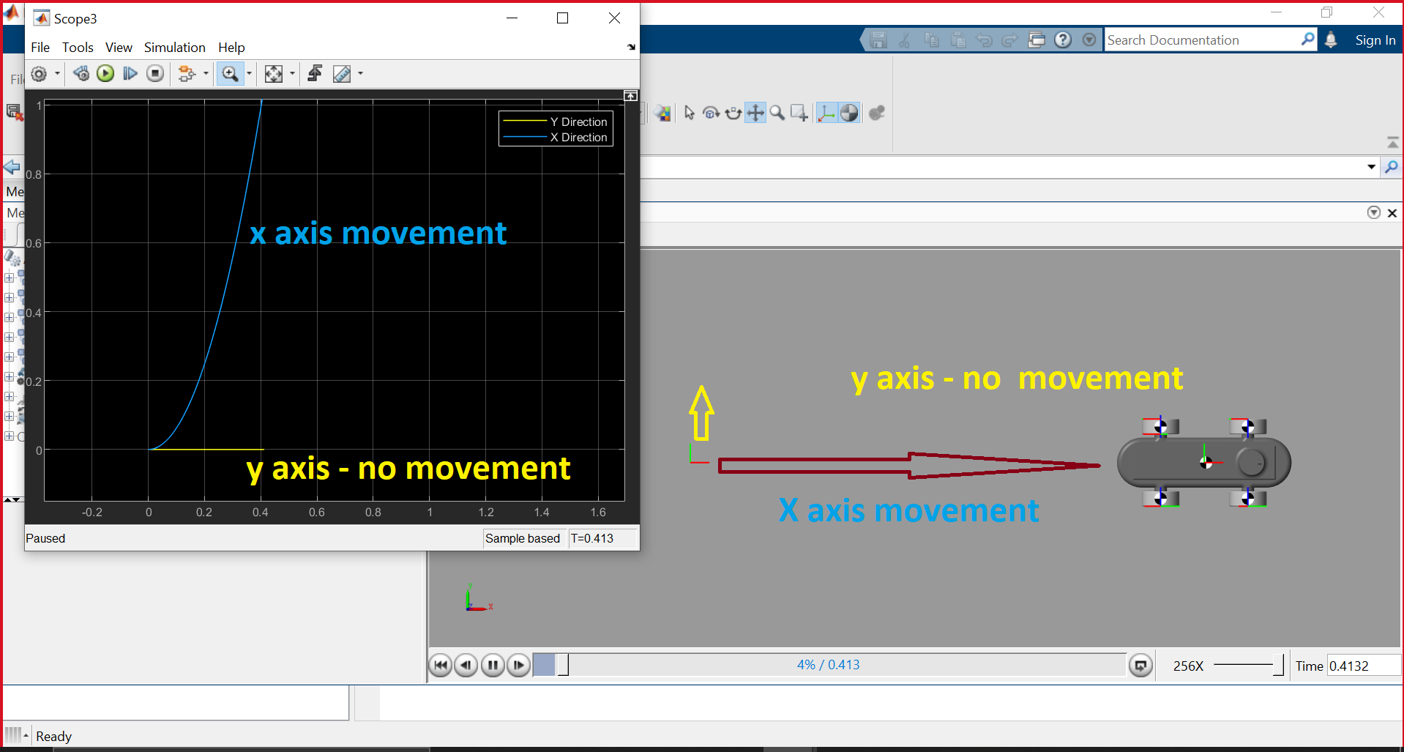

## Fig 11. Simulation of Model Forward motion

## CurveUpdated

## Fig 12. Simulation of Model Curve Negotiation

**OUTPUT**

**INFERENCE**

**RESULT**

Thus, the modeling and simulation of Wheeled Mobile Robot using SolidWorks and MATLAB has been done